ICAD&M14 Conference –Extended Abstract
First A. Author^{#1}, Second B. Author^{*2}, Third C.D. Author^{#3}
#First-Third Department, First-Third University, Address Including Country Name
¹first.author@first-third.edu, ³third.author@first-third.edu
*Second Company, Address Including Country Name
²second.author@second.com
Keywords— Include at least 3 keywords or phrases

Extended ABSTRACT
This document is a template. An electronic copy can be downloaded from the conference website. For questions on paper guidelines, please contact the conference paper committee as indicated on the conference website. Information about final paper submission is available from the conference website.
An easy way to comply with the conference paper formatting requirements is to use this document as a template and simply type your text into it.
- Page Layout
Extended abstract is one to two pages. Your paper must use a page size corresponding to A4 which is 210mm (8.27") wide and 297mm (11.69") long. The margins must be set as follows:
- Top = 19mm (0.75")
- Bottom = 43mm (1.69")
- Left = Right = 14.32mm (0.56")
Your paper must be in two column format with a space of 4.22mm (0.17") between columns.
All paragraphs must be indented. All paragraphs must be justified, i.e. both left-justified and right-justified.
- Text Font of Entire Document
The entire document should be in Times New Roman or Times font. Type 3 fonts must not be used. Other font types may be used if needed for special purposes.
Recommended font sizes are shown in Table 1.
- Title and Author Details
Title must be in 24 pt Regular font. Author name must be in 11 pt Regular font. Author affiliation must be in 10 pt Italic. Email address must be in 9 pt Courier Regular font.

TABLE I
Font Sizes for Papers
Font Size | Appearance (in Time New Roman or Times)
Font Size | Regular | Bold | Italic
8 | table caption (in Small Caps),  figure caption,  reference item |  | reference item (partial)
9 | author email address (in Courier),  cell in a table | abstract body | abstract heading (also in Bold)
10 | level-1 heading (in Small Caps),  paragraph |  | level-2 heading,  level-3 heading,  author affiliation
11 | author name
24 | title

All title and author details must be in single-column format and must be centered.
Every word in a title must be capitalized except for short minor words such as “a”, “an”, “and”, “as”, “at”, “by”, “for”, “from”, “if”, “in”, “into”, “on”, “or”, “of”, “the”, “to”, “with”.
To avoid confusion, the family name must be written as the last part of each author name.
Each affiliation must include, at the very least, the name of the company and the name of the country where the author is based.
Email address is compulsory for the corresponding author.
- Content
The abstract should give a clear indication of the objectives, scope, results and conclusion of your work. Introduction will give a background on the subject. Materials and methods will be presented as applicable followed by results and discussion. It is recommended to limit the number of references to five.
- Figures and Tables
One figure and one table can be included in your extended abstract. Figures and tables must be centered in the column. Large figures and tables may span across both columns. Any table or figure that takes up more than 1 column width must be positioned either at the top or at the bottom of the page.
Graphics may be full color. All colors will be retained on the PDF. Graphics must not use stipple fill patterns because they may not be reproduced properly. Please use only SOLID FILL colors which contrast well both on screen and on a black-and-white hardcopy, as shown in Fig. 1.

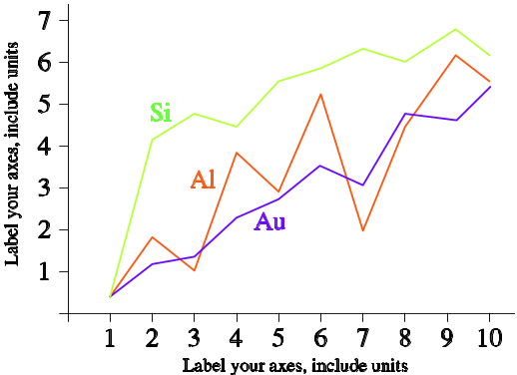
Fig. 1 A sample line graph using colors which contrast well both on screen and on a black-and-white hardcopy
- References
- Van der Geer J, Hanraads JAJ, Lupton RA. The art of writing a scientific article. J Sci Commun 2000;163:51–9.
- Strunk Jr W, White EB. The elements of style. 3rd ed. New York: Macmillan; 1979.
- Mettam GR, Adams LB. How to prepare an electronic version of your article. In: Jones BS, Smith RZ, editors.Introduction to the electronic age, New York: E-Publishing Inc; 1999, p. 281–304.

